­­Surtej Sarin

Professor Justh

CMSC 203 – 30963

Project 1

2/4/15

External documents

**Algorithm Design/Pseudo-code:**

To begin your program, include the scanner library class *java.util.Scanner* which allows the computer to read user input from the keyboard. Then you must create the class called *EvalFunction* and next create the void main program defined as *public static void main(String[] args).* Inside the main program you will need to include *Scanner keyboard = new Scanner(System.in)* so that the keyboard may read the user input. Next, you must initialize and define the variables used in the program (must include x-value, y-value) in the data type double with the assigned value 0.0. Then, print the following display to the console: the title “program to evaluate a function...” in addition to the printing the function: “compute the value of the function f(x) = 2*x^3 – 5*x^2 – 12*x + 4.” Ask the user to “enter the value of x for which f(x) will be evaluated” and use *x= keyboard.nextDouble()* to assign the value entered by the user (this is why we must use the scanner library). Next step is the calculation portion of the program. Calculate the function by using the math power function, *Math.pow(a,b) where a=x-value and b=power*, assign x in the variable of the equation, and make it all equal to the f(x) or y-variable*.* At the end of your program, display the value of f(x) from the calculations and finally display a closing message, “Goodbye – <your name>.”

**Class documentation:**

In this program the class EvalFunction prompts the user for input and assigns it to the x variable. It then performs a calculation using the function f(x) = 2*x^3 – 5*x^2 – 12*x + 4") and uses the math power operator. It displays the calculated f(x) or y-value to the display screen.

List of variables used in code with descriptions (all doubles and initialized to 0.0):

**double** x=0.0; //this variable is the x-value entered by the user

**double** xPow3=0.0; //the value of x raised to the power of 3

**double** xPow2=0.0; //the value of x raised to the power of 2

**double** xPow1=0.0; //the value of x raised to the power of 1

**double** y=0.0; //the y value or F(x) which = 2*x^3 – 5*x^2 – 12*x + 4

**Test cases: (table format answered by calculator and program)**

|  |  |  |
| --- | --- | --- |
| x-value | F(x) or y-value (hand calculated) | F(x) or y-value (program calculated) |
| -3 | -59.0 | -59.0 |
| 0 | 4.0 | 4.0 |
| 4.5 | 31.0 | 31.0 |
| -1.7 | 0.12400000000000233 | 0.12400000000000233 |
| -5.5 | -414.0 | -414.0 |

**Assumptions:**

The user of the program will enter valid numerical values for the x variable (this should be within the double-type restraints). They will not enter extraneous characters or char/string characters for the x variable. (This way one may prevent the result of errors in the program).

**Program Detail/3 screenshots:**

1 java program

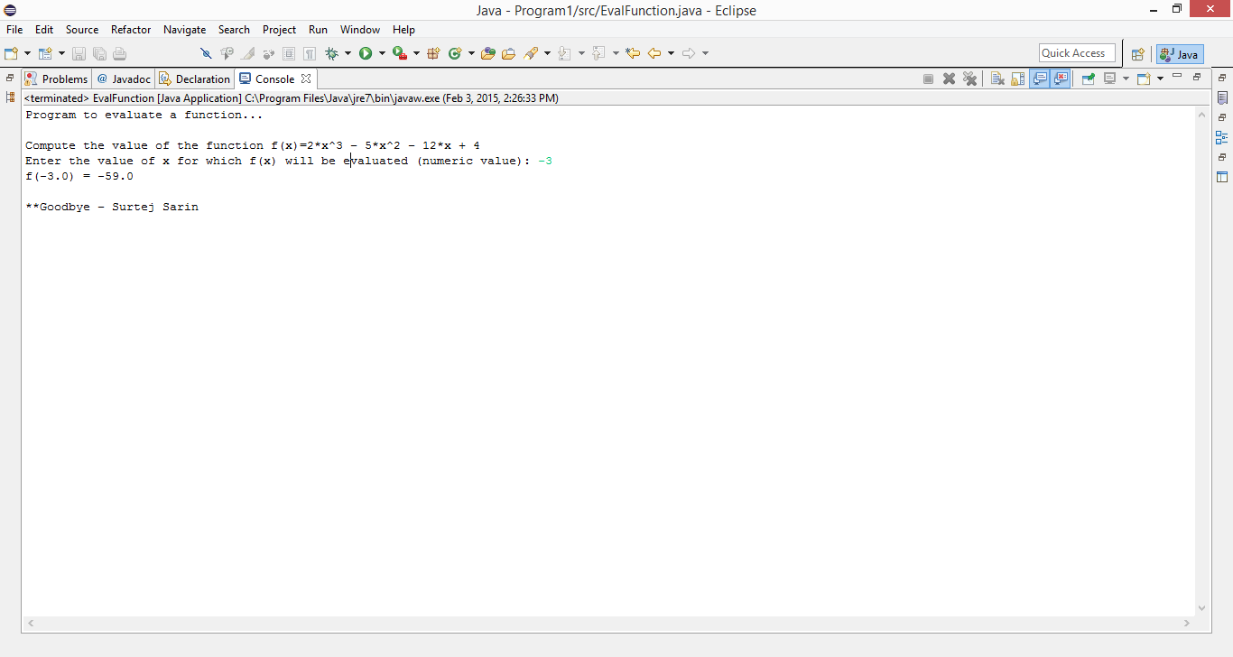

2 cmd - command prompt

